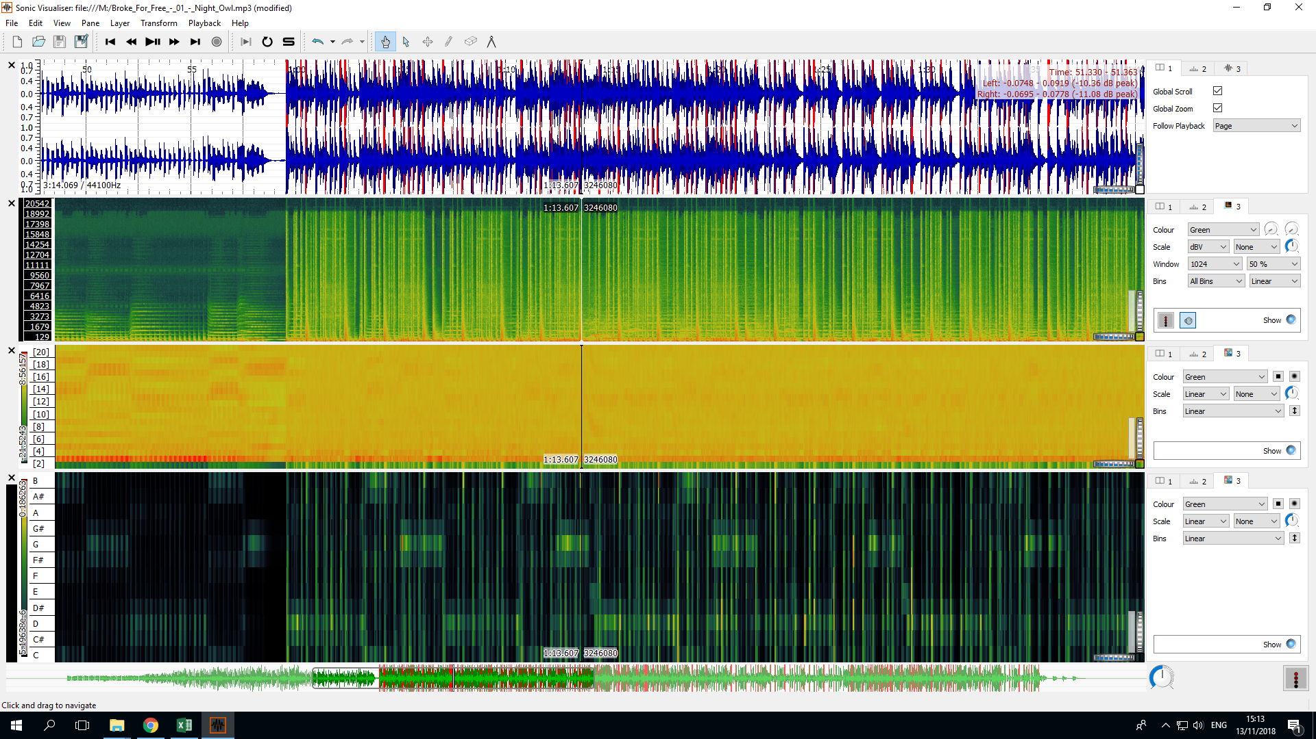**NIGHT OWL BY BROKE FREE, ELECTRONIC:**

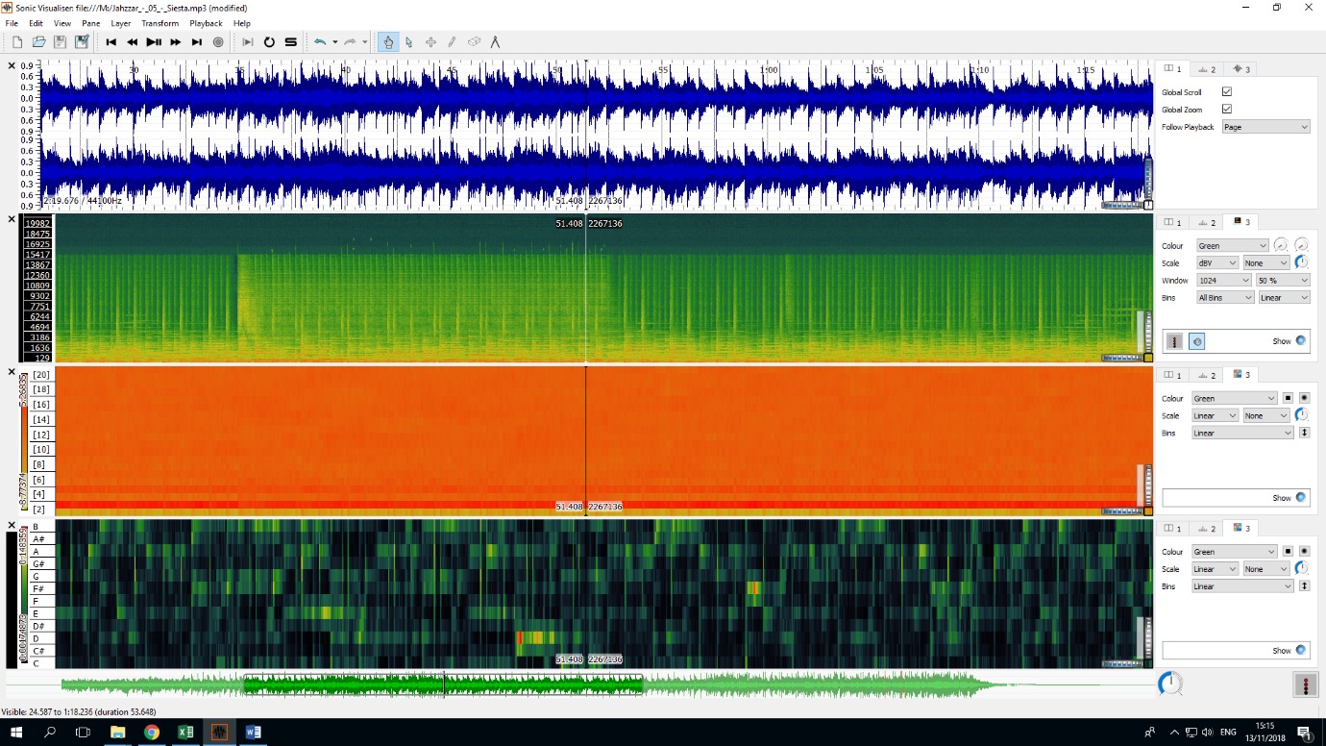**SIESTA BY JAHZZAR, POP/INDIE-ROCK:**

**FATER LEE BY BLACK ANT, HIP-HOP:**

